- Develop a lexical Analyzer to identify identifiers, constants, operators using C program.
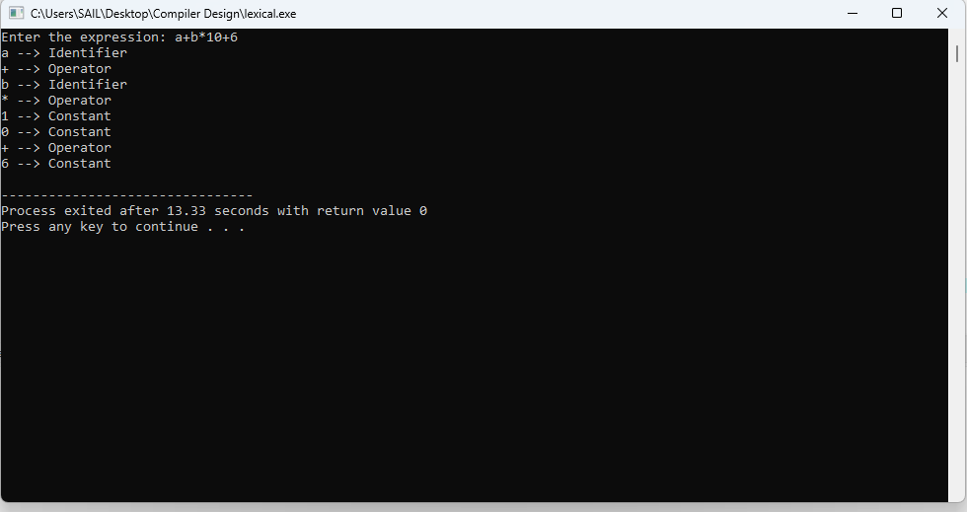

- Develop a lexical Analyzer to identify whether a given line is a comment or not using C

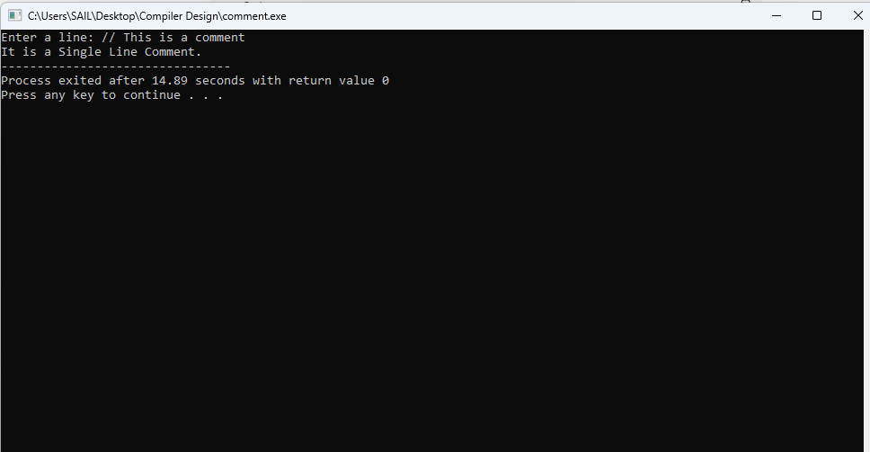

Design a lexical Analyzer for given language should ignore the redundant spaces, tabs and new lines and ignore comments using C

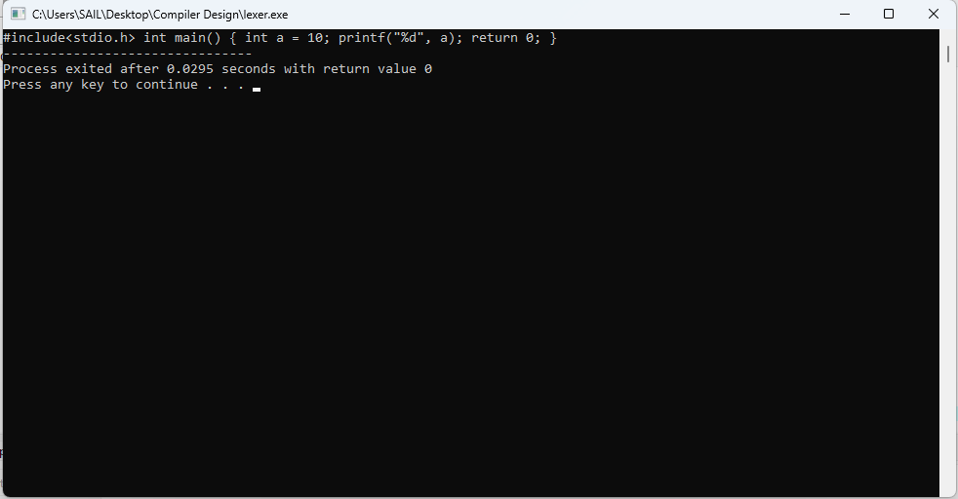
- Design a lexical Analyzer to validate operators to recognize the operators +,-,*,/ using regular arithmetic operators using C

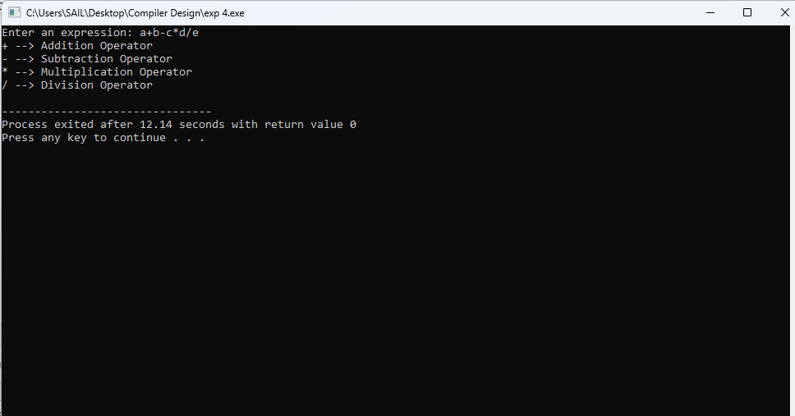

- Design a lexical Analyzer to find the number of whitespaces and newline characters using C.

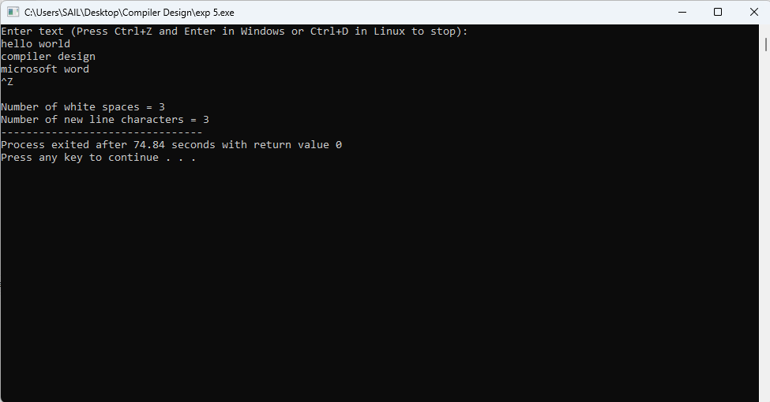

- Develop a lexical Analyzer to test whether a given identifier is valid or not using C.

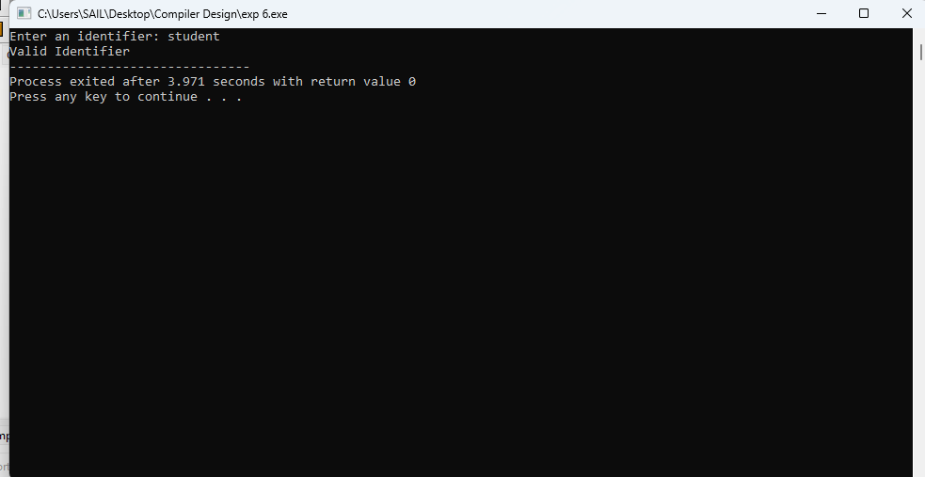

- Write a C program to find FIRST( ) - predictive parser for the given grammar
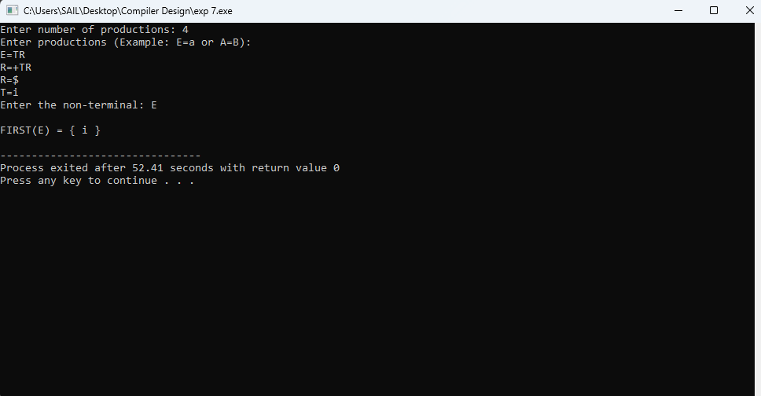

- Write a C program to find FOLLOW( ) - predictive parser for the given grammar

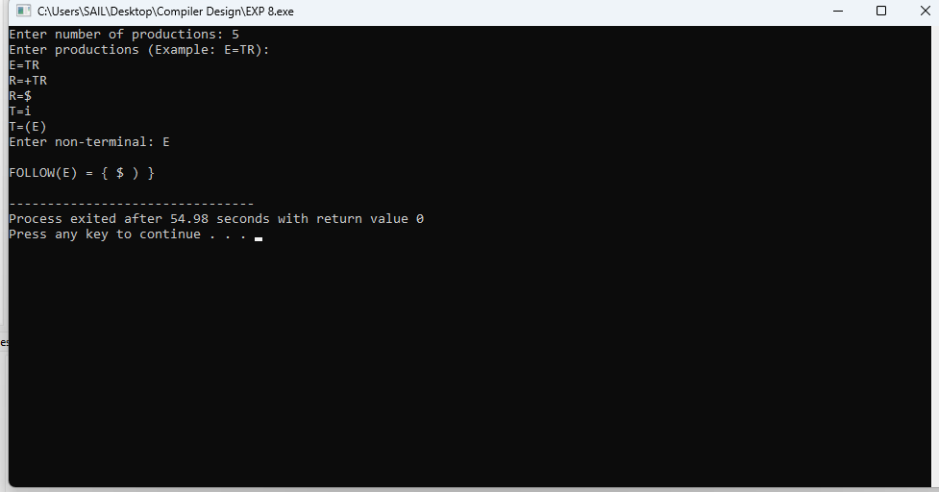

- Implement a C program to eliminate left recursion from a given CFG.
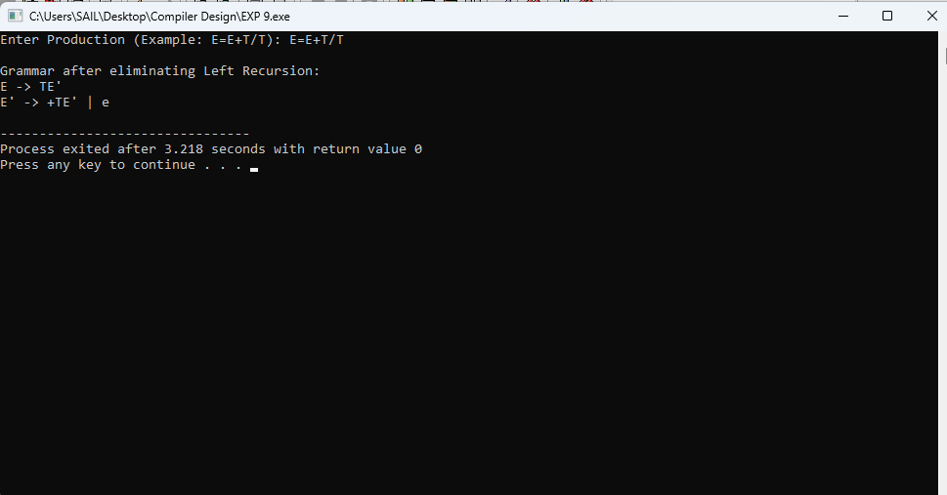

Implement a C program to eliminate left factoring from a given CFG.

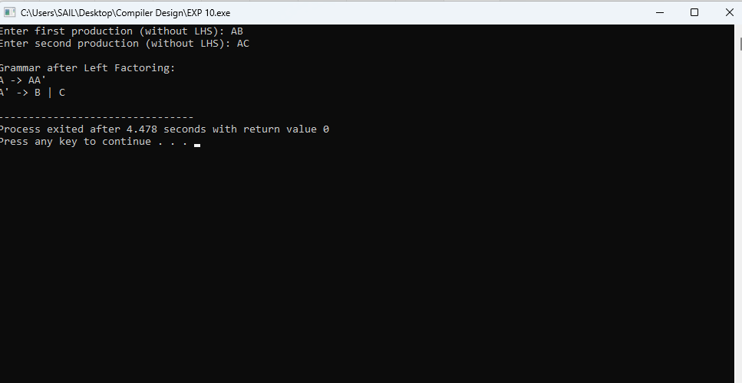

Implement a C program to perform symbol table operations.

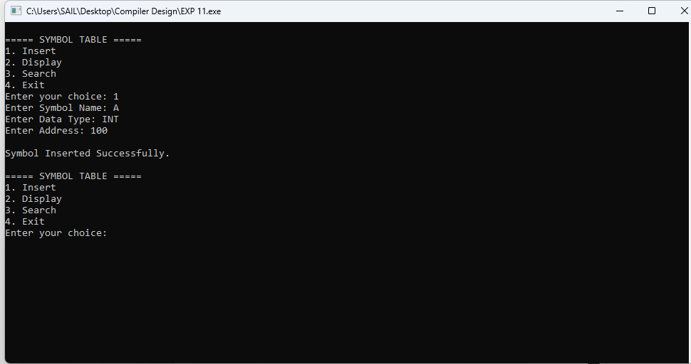

Write a C program to construct recursive descent parsing for the given grammar

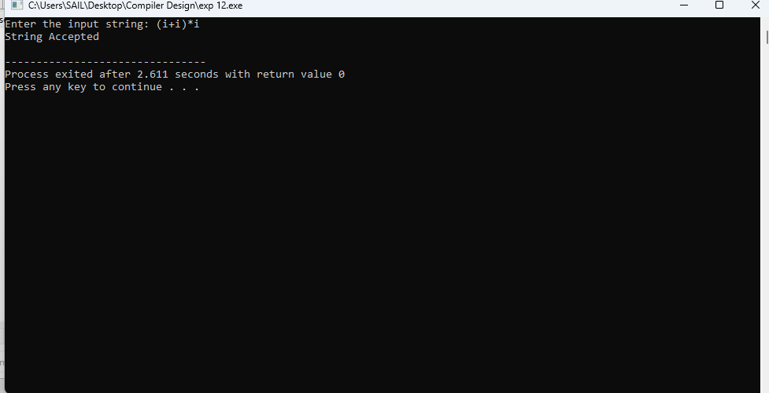

Write a C program to implement either Top Down parsing technique or Bottom Up Parsing technique to check whether the given input string is satisfying the grammar or not.

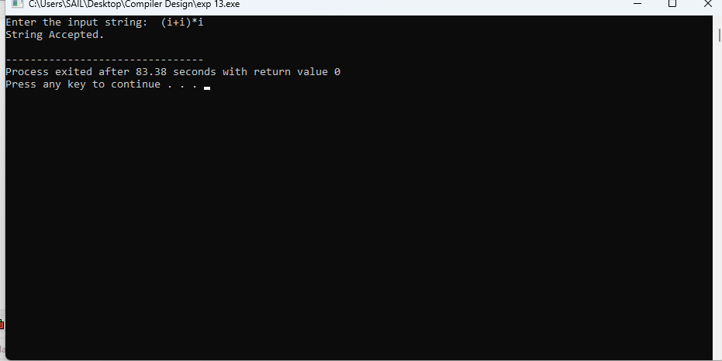

Implement the concept of Shift reduce parsing in C Programming.

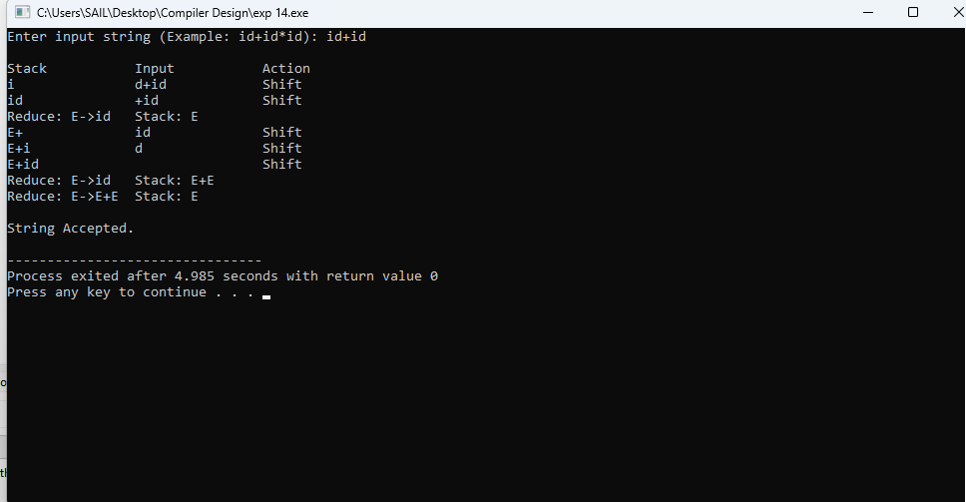

Write a C Program to implement the operator precedence parsing.

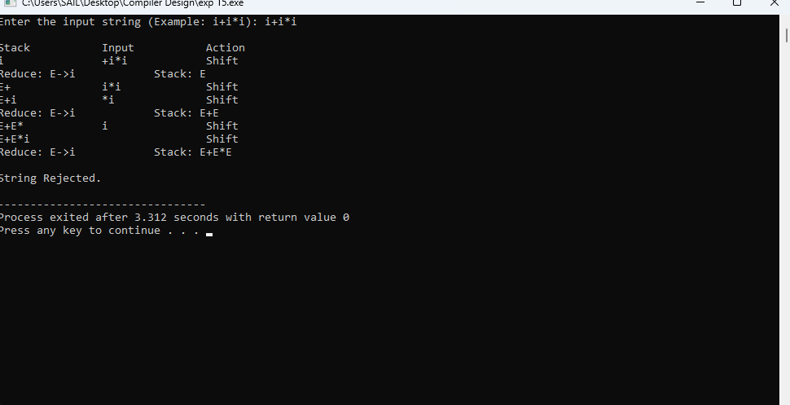

Write a C Program to Generate the Three address code representation for the given input statement.

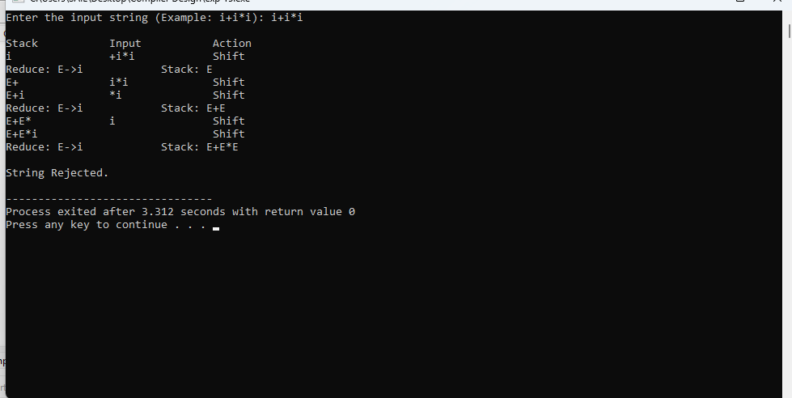

Write a C program for implementing a Lexical Analyzer to Scan and Count the number of characters, words, and lines in a file.

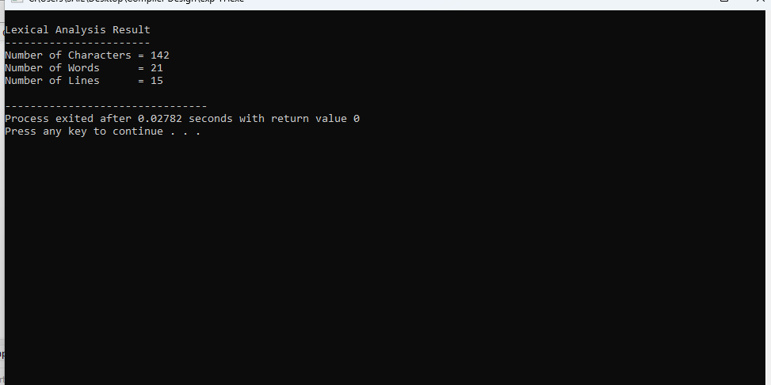

Write a C program to implement the back end of the compiler.

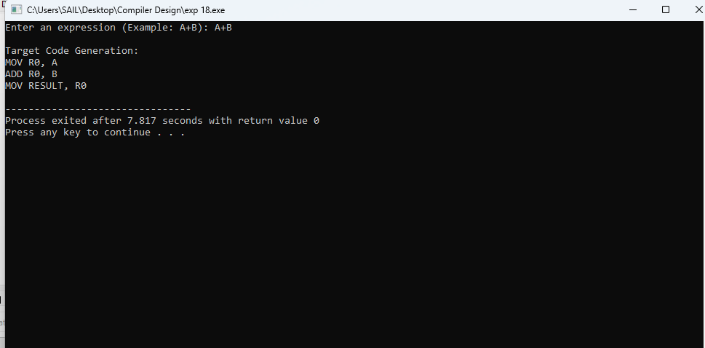

Write a C program to compute LEADING( ) – operator precedence parser for the given grammar

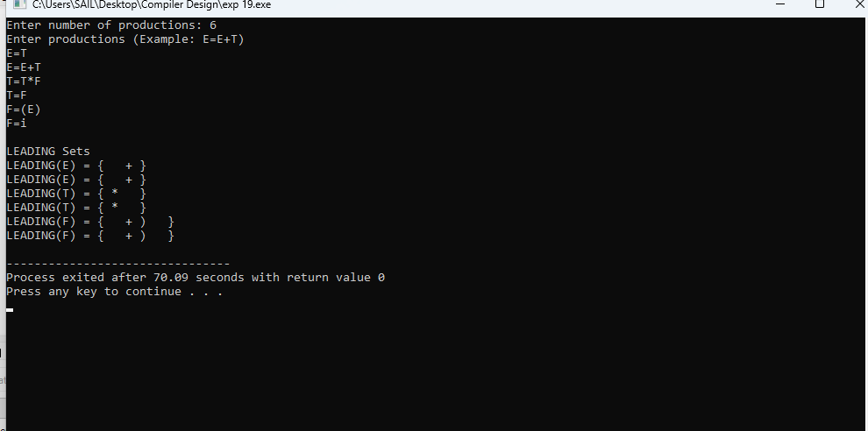
- Write a C program to compute TRAILING( ) – operator precedence parser for the given grammar

